Analysis of Biomedical Images through Deep Learning Model for the Identification of Diseases

P.Pandiaraja
School of Computing, Department of Computer Science and Engineering
Vel Tech Rangarajan Dr.Sagunthala R&D Institute of Science and Technology, Chennai – 600 062. sppandiaraja@gmail.com
N Sai Mahesh teja
School of Computing, Department of Computer Science and Engineering
Vel Tech Rangarajan Dr.Sagunthala R&D Institute of Science and Technology , Chennai – 600 062. nsaimaheshteja1@gmail.com
N Jogi sai ratna kishore Reddy School of Computing, Department of Computer Science and Engineering
Vel Tech Rangarajan Dr.Sagunthala R&D Institute of Science and Technology, Chennai – 600 062. vtu21306@veltech.edu.in

T Pavan Kumar Reddy School of Computing, Department of Computer Science and Engineering
Vel Tech Rangarajan Dr.Sagunthala R&D Institute of Science and Technology, Chennai – 600 062. vtu19022@veltech.edu.in

Abstract Early disease diagnosis carries paramount importance since it enables better treatment approaches which result in superior patient recovery. The development of convolutional neural networks (CNNs) within deep learning has led to automated disease detection which functions more fast, accurate and economically beneficial. X-rays together with CT scans make essential contributions to identify different medical conditions through medical imaging procedures. Deep learning models consume large databases of medical images for effective multiple disease detection through training. Organizations benefit from the proposed deep learning approach because it offers both reliable detection capabilities and practical implementation opportunities in clinical environments. Medical image analysis enables the system to help doctors reach well-informed decisions in a more efficient way. Healthcare organizations can implement this adaptable lightweight design across their hospitals and primary care facilities at a low cost.

Keywords: Relative convolution neural network, frequency sub-bands, X-Ray, CT scans, Deep Learning.

Introduction
Deep learning applications and Artificial intelligence (AI) models present a significant potential for enhancement of human life. Such systems have the capacity to improve life quality for many people through streamlined processes. time. Pattern recognition, image mining, and machine All these concepts merged together now function as a system which retrieves analyzes and creates visualizations. The information system allows medical imagery analysis through visualization and image processing. processing. Recent advancements in
deep learning and Artificial intelligence (AI) through recent
advancements created substantial improvements in mankind. significant improvements in healthcare. By integrating pattern recognition, and machine learning, medical image Medical image processing receives elevated operational abilities through improved capabilities in the recent times. image acquisition, analysis, and visualization. Deep neural networks—especially convolutional neural networks (CNNs)—have become invaluable in diagnosing diseases, enabling precise segmentation, registration, and classification of medical images .The utilization of technology brings about better diagnostic precision together with several other benefits. The system advances both medical research investigations as well as patient-specific treatment approaches. strategies. These methods produce considerable benefits in medical applications classifying illnesses, detecting malignancy, an segmenting organs.

RERELATED WORK
An absolutely essential element in the software development process is literature evaluation. Determining the time component, cost savings, and commercial business robustness is essential before expanding the gadget. After requirements are satisfied, the next stage is to identify the operating system and language that can be utilized to expand the device. Programmers require a lot of outside assistance once they begin building a device. Books, websites, or veteran programmers can all provide this assistance .The aforementioned issues are taken into account when constructing the system in order to expand the suggested device.

Examining and reviewing all of the challenge improvement's needs is the core function of the assignment improvement department. The most crucial stage in the software program development process for each project is the literature assessment. Prior to expanding the equipment and associated layout, time considerations, resource requirements, labor, economics, and organizational electricity must be identified and assessed. The next phase is to determine the operating system needed for the project, the software program specifications of the particular computer, and any software programs that need to be carried on after those factors have been met and thoroughly investigated. A move similar to expanding the tools and related capabilities
In this current world, large amount of data are and strategy to overcome these challenges, particularly when signals are inherently sparse or can be efficiently compressed. Compared to conventional techniques, it might be used to recover compressive or light signals with less estimation. CS must address two issues creating an effective sparse recovery algorithm and building the estimating framework. The main objective of this study is to have certain concepts and applications of compressive sensing and to present an overview of the most significant sparse recovery computations from each class. The display of acquisition and reconstruction processes is tested in terms of the Compressed Ratio, Reconstruction Accuracy, and other metrics.[1].
introduced shared every day. This entails using more power, spending a lot of energy, and depleting a lot of memory. at some applications, such as image processing, signal visualization, and data signal possession, among others, the signals included can be compared to light at specific locations. Compressive sensing emerges as a viable
High eye pressure generally affects the nerves of the brain. Sometimes the only sign of the most prevalent type of glaucoma is a progressive loss of vision. In this work, the Maximum Likelihood Classifier (MLC) and other entropy features are used to create the Glaucoma Image Classification (GIC). Before features are retrieved using entropy features such, Shannon entropy, and approximation entropy, the input retinographies are first deconstructed using the rankles transform. Ultimately, vi is categorized using MLC. The function of the GIC system provides a 96% classification accuracy by utilizing MLC and the Shannon entropy characteristic. [2].
Many imaging-related problems can be effectively solved with computer vision, including automatic image segmentation and classification. Images can be automatically tagged and objects recognized by using models that have been artificially trained. Industrial cameras are used in large-scale manufacturing to continuously capture photos of components for various purposes. Some poor photos are acquired due to
motion, lens distortion, and noise restrictions; these images need to be recognized and classified. Manually inspecting these photos is a popular solution to this issue. But in addition to taking a long time, this technique is also unreliable. The study suggests an artificially intelligent system that uses deep learning and can quickly learn to recognize and classify erroneous photos. This is accomplished by extracting distinguishing characteristics from the dataset using a pre trained convolution neural network built on the PyTorch framework, which is then used to the classification problem. Additionally, Dropout technology was used in the suggested model to modify the network and remove the possibility of over fitting. According to the experimental study, the system has an accuracy of more than 91% in accurately classifying normal and faulty photos [3].
Time has become incredibly valuable as a result of rapid urbanization and migration from rural to urban areas. The desire for speed and efficiency has increased due to changes in people’s lifestyles. In industries such as grocery retail, manual item identification and billing remain time-consuming because products often lack barcodes—forcing billers to manually enter names or weigh items, thereby doubling the workload[4].
The process of training a deep neural network can be expensive in terms of time and computational resources, and it often demands extensive datasets that are not always readily available. These challenges can be mitigated by reusing model weights from previously trained models on established computer vision benchmark datasets. The basic idea behind transfer learning is to identify the information from one task to improve generalization on another. In this approach, a network’s learned weights from "task A," which has abundant labeled data, are applied to "task B," which may have less data. For example, the training data of a simple classifier might be repurposed to identify additional objects—such as beverages— if it was originally trained to detect food. This transfer of knowledge can take various forms, allowing practitioners to use high-quality pre-trained models directly or fine-tune them for specific applications. As a result, the performance of deep learning models can be enhanced and training times reduced even when data is limited. In the current study, we propose using three pre-trained models—Mobile Net V2, ResNet50, and VGG19—to perform the classification task, employing four key evaluation criteria to compare model performance relative to a defined objective. [5]
A deep learning-based decision support system for modalities brain tumor categorization was presented by Sharif et al. in 2021. In order to improve classification accuracy, their method combined data from CT and MRI scans and used convolutional neural networks (CNNs). By automating tumor identification and classification, the technology sought to help radiologists by lowering diagnostic errors The study demonstrated an exceptional The system demonstrated

outstanding capabilities to detect delicate and intricate organizations within medical pictures. images, outperforming conventional machine learning techniques. This approach experienced multiple difficulties while operating. The analysis faces two main difficulties including excessive computing needs along with unbalanced datasets. The next generation of this technology might include larger datasets as a key feature. The advancement of both datasets and interpretability methods within the model would help its clinical application process. facilitate clinical implementation. Overall, this research This research advances significantly the capacity of AI systems to assist early detection procedures diagnostic systems for brain tumors. [6]
The 2022 development of a framework emerged from Phaphuangwittayakul et al. The deep learning framework develops methods for diagnosing multiple forms of brain pathologies. hemorrhagic traumatic brain injury (TBI) patients. Their approach utilized convolutional neural network The deep learning frameworks enable detection of hemorrhages along with their quantification including intracerebral, subarachnoid, and epidural hematomas. The planned automated diagnostic procedure enhanced diagnostic capabilities in this system. The framework cut down the need for human operators through automation of analysis processes. The diagnostic process benefited from automated interpretation which led to better accuracy levels while also increasing efficiency levels. efficiency. Techniques such as image augmentation and Through transfer learning the model became more sturdy when handling diverse datasets.diverse datasets. The system incorporated a significant feature which allowed for the detection of hemorrhages from various types. The lesion quantification module uses a system that allows for very precise measurements. Hemorrhage size estimation stands as a fundamental diagnostic element needed for proper clinical care. clinical decision-making. Although the study underscored the promise of AI in emergency and critical care Moreover the research pointed to future work requirements which should be pursued. into data diversity and real-world validation. [7]
The researchers from Tappero et al. (2020) studied Since 2008 researchers have applied postmortem computed tomography (PMCT) for Medical experts investigated the capacity to diagnosis brain hemorrhages in decomposed human remains through postmortem computed tomography scans. The authors conducted research to develop forensic pathology through making advancements. Their work Researchers evaluated the ability of detecting hemorrhagic areas despite tissue decomposition. identified despite tissue decomposition. By comparing By studying PMCT results together with histological analyses the researchers managed to demonstrate their findings. The researchers demonstrated through their work that scan density variations functioned as an effective diagnostic method the distinction between subdural and
subarachnoid hemorrhages. The research established that PMCT develops into a reliable investigative instrument. valuable non-invasive forensic tool, particularly in cases where traditional autopsies are impractical. Nonetheless, The technique faces obstacles which include the formation of gases together with scan distortion. in degraded tissues were observed. Future developments Future development in this field might use computerized image processing technology with AI capabilities to enhance detection abilities. The identification of hemorrhages in forensic investigations will undergo enhancement through technological improvements. [8]
The research team of Yu et al. established an AI prediction system for stroke detection that used bio signals from PPG and ECG in 2022. This study developed an AI prediction model which integrative bio signal data from PPG and ECG for stroke assessments. photoplethysmography (PPG) and electrocardiograms (ECG). Their model, which combined recurrent neural networks (RNNs) with deep neural networks (DNNs), The system aimed to analyze heart patterns during cardiac rhythm evaluation for stroke risk prediction stroke risk
Critical features—such as heart rate variability (HRV) and atrial fibrillation detection—were extracted to enable real-time stroke assessment. The system achieved superior prediction accuracy compared to conventional techniques, opening the door for early intervention and continuous monitoring through integration with wearable technology. However, challenges related to real-world validation and data variability remain, and future research supported by larger datasets and comprehensive clinical trials is expected to further enhance the model's resilience. [9]
Used biomarkers based on speech and movement, Lamba et al. (2021) created a hybrid machine learning model for the diagnosis of Parkinson's disease (PD). To categorize Parkinson's patients, their approach included deep learning models, Random Forest (RF), and Support Vector Machines (SVM). The model demonstrated significant diagnostic accuracy in early Parkinson's disease identification by extracting speech abnormalities and tremor characteristics. The study demonstrated AI's potential for non-invasive diagnosis, which will help neurologists monitor patients' conditions. Nevertheless, difficulties were observed, including biases in the dataset and variations in patient symptoms. To improve diagnostic accuracy in the future, multi-modal data integration (such as imaging and gait analysis data) may be used. This research advances the diagnosis of neurodegenerative diseases using AI. [10]

EXISTING SYSTEM
In high-resolution 3D ultrasound imaging, a massive data collection of received multiple echo responses is necessary to reconstruct each image line. Hardware-driven solutions include
beam-forming up to 32 × 32 channels using a low-consumption

FPGA, or micro beam -forming the entire raw radio-frequency (RF) data using specialized electronic circuits on a matrix probe. As the transducer's surface area increases, so does the necessary data bandwidth, The available resources for large phased array sensors surpass what is needed for bigger systems. The paper seeks to overcome data transfer limitations through sparse regularization techniques that reconstruct RF channel information from minimal measurement points at the probe. Linear combinations of a simulated sample of system point spread functions (PSF) create the complete data set. The processing operations create shift-sensitive bent wave dictionaries adapted to particular shapes during acquisition. During reconstruction the least squares technique ensures reliable recovery of complete RF channel data productsRF
- Image quality and variability.
- Food item classification challenge.
- Surface area detection issues.
- Calorie prediction accuracy.

REQUIREMENT ANALYSIS
Evaluation of the Rationale and Feasibility of the Proposed System
Given the rising complexity of medical imaging and the demand for higher diagnostic accuracy, the proposed deep learning system is critical for enhancing biomedical image processing. By automating image processing with The implementation of deep learning technology allows healthcare personnel to dedicate their time to complicated cases and achieve fast reliable assessments. The system maintains its speed in delivering accurate results when handling difficult cases. results. This implementation strategy achieves practicality because of modern advancements. technological advancements, the availability of vast biomedical datasets, and the potential for significant cost savings in healthcare. Moreover, in a market increasingly This solution advances because of accelerating digital health innovations throughout the market. complies with regulatory standards. Overall, the adoption This technology will boost patient outcomes through its implementation. outcomes and streamline clinical procedures.

PROPOSED SYSTEM
A transformation of data employs back projection as the method .The detector (projection space) to the image space by The acquired information receives distribution within the measurement direction during the transformation process. measurement direction. Owing to its simplicity, computational efficiency, and reliability, The back-projection algorithm stands as one of the most popular choices to reconstruct images
from the detector data. images in circular-scanning photo
acoustic tomography. In biomedical analysis, deep learning leverages Nervous system networks with advanced functionality extract and analyze and interpret complex features from medical images. The technique helps scientists to extract difficult-to-detect complex imaging elements in medical pictures. This integration of traditional image reconstruction with Such advanced neural network methods improve image quality through two mechanisms which enhance diagnostic precision. The implementation of this combination leads to enhanced picture clarity as well as better accurate medical diagnoses. through automated pattern recognition merits
- Enhanced accuracy and precision.
- Automation of routine tasks.
- Handling larger and complex data.
- Personalized machine.

SELECTED METHODODLOGIES
- API
Matrix Laboratory gets its abbreviation form as MATLAB. Rather than working with discrete The high level programming language known as integers operates at a platform that uses arrays instead of individual integers. The platform functions with arrays and matrices as its base components. MATLAB Books across national departments use MATLAB as their main educational tool in textbooks. The language serves college students who study mathematics together with engineering students due to its features. The original purpose of this system aimed to meet the requirements of scientists and engineers. mind. The method offers users the most straightforward route for direct operations perform matrix and array computations. Additionally, the Function Store further extends MATLAB's capabilities by offering an extensive library of computational algorithms.
Handle Graphics is a MATLAB concept and practice. A handle to the graphics object will be returned by almost all charting functions. These handles allow you to view, modify, and access all of the object's properties. Application Programming Interface is referred to as API. Although MATLAB is a standalone environment, it also supports external programs and interfaces through an API. It can be used to launch C or Fortran programs from MATLAB, import, export data, and enable client/server communication with other applications.
- Deep Learning
Deep learning is a branch of artificial intelligence that same as the complex workings of the human brain using sophisticated neural network structures. In everyday life, many of the AI applications we depend on, whether digital assistants, voice-controlled devices, or fraud detection systems, rely on deep learning technologies. Unlike traditional machine learning, which Traditional neural networks in practice only

use one to two layers for processing. A deep learning model features numerous layers in its structure on top of two basic layers. The modeling network contains multiple layers which can reach numbers ranging from hundreds to thousands to discover complicated patterns. understand intricate patterns
.Traditional machines operate differently from deep learning platforms because they use one or two neural layers in their structure. General learning models function optimally based on dataset labels that have been precisely defined. Due to deep learning ability to learn from both labeled and unlabeled datasets it becomes effective in its operation. both labeled and unlabeled data. This flexibility allows The deep learning systems analyze raw unstructured information through their deep architecture. The system identifies crucial information elements while extracting key characteristics that help it learn progressively. These systems automatically improve their output results to achieve better precision.Deep learning has produced a significant advancement in all operational processes. automation in various fields. As an enabling force it drives modern operations. many everyday innovations, from self-driving cars to Modern security systems operate along with new high-end technologies that enhance human technology interactions technology more efficient and reliable.
- Convolutional Neural Networks (CNN)
Deep convolutional neural networks (CNNs) The diagnosis of illness has undergone dramatic changes because of its implementation. medical picture classification. CNNs excel at tasks such as image classification, and disease detection by leveraging deep learning methods. This technology The system demonstrates potential to generate better healthcare results by using its extensive catalog of possibilities. The system demonstrates potential to raise diagnosis precision together with processing effectiveness. diagnostic imaging. The human visual cortex was the inspiration for the concept. A specific version of artificial neural networks exists for this purpose. computer vision tasks. They consist of multiple layers The convolutional layers make use of filtering systems to extract important features from images and object inputs. The pooling layers reduce spatial features within critical features. The fully connected layers serve as the conclusion to the computation process in the neural network alongside pooling and convolutional layers. classification process. Their robust ability to detect, The ability of computers to detect and segment and assign categories to different medical conditions demonstrates how effective CNNs have become in the field. Thanks to their effectiveness CNNs have become crucial technology for medical image assessment. A specific A 2D-to-3D conversion process is achieved through the specified convolutional filter. 3D representations ensures optimal performance with two- dimensional images. Despite their remarkable Although quick in learning process and performance improvement CNNs need extensive data for their operation. The success of classification
requires a large amount of input data and CNNs face difficulties from human errors while searching for local minima. There are two main problems facing the CNN technology which include local minima plus significant human error.. The breakthrough performance The success of AlexNet in 2012 confirmed that CNNs had achieved wide recognition as essential tools for medical image processing to support clinical practice. CNNs have established themselves as fundamental instruments for progressing medical image processing. and supporting clinicians. Recurrent Neural Network (RNN)The recurrent neural network (RNN) Classification represents a separate network category. Machines with artificial neural networks serve as a specific network model for sequential tasks sequential inputs. The neural networks successfully manage multiple types of analytical processes. Seminar data of time-series format and natural language documents The memory features of these networks enable their application in processing due to their built-in recall capabilities. The system incorporates a dependency recording capability enabling them to extract useful information from context. between consecutive inputs. This capability makes RNNs ideal for applications such as time series analysis, language modeling, where the sequence and context of the accurate predictions depend heavily on data integrity.
- Recurrent Neural Network (RNN)
Recurrent neural networks (RNNs) are a distinct class of artificial neural networks created for handling the sequential inputs. They are particularly valuable for tasks participating time-series data or natural language processing because of their inherent memory mechanism, which allows them to capture and utilize dependencies between consecutive inputs. This capability makes RNNs ideal for applications such as time series analysis, language modeling, where the sequence and context of the data are crucial for accurate predictions.

SYSTEM ARCHITECTURE
The system design can be understood better through a basic illustration. A system becomes more apparent with graphical representation that shows input data transportation through successive operations to generate final outputs. Various operations apply to manufacturing the end product. This visual The graphical approach functions to show how data processing takes place transformed within the system It is used to model the system's components. These components include the process of the system, the data it consumes, an external communication channel, and the information flows that occur within it. This demonstrates how information transfer to the system and the different changes that make it different. This approach illustrates the flow of information and the modifications made to data as it moves from input to output through the use of images in Fig 1.

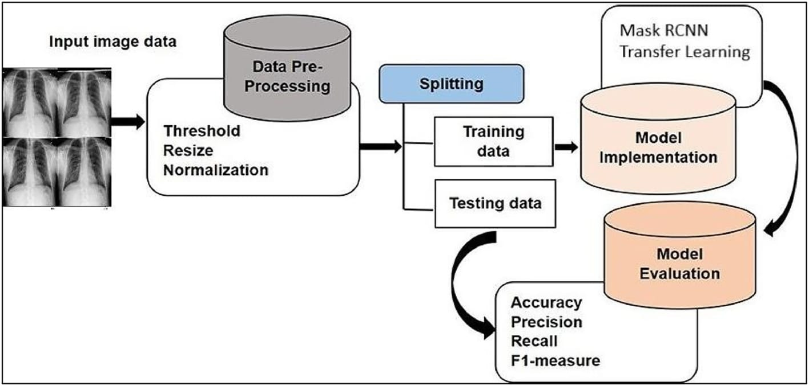
Fig.1 Proposed System model for Identification of Diseases

SYSTEM MODULES
- Image acquisition
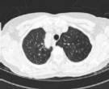
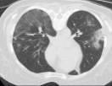
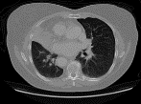
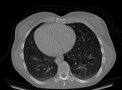
Image acquisition is the process of acquiring the image sources from hardware systems such as cameras, data base and sensors.
- Preprocessing
Additional image processing methods will be applied in the pre-processing stage to improve image quality while removing noise from the detected heart and blood vessels.
IA beginning collection of raw data is divided and processed to set of meaning full features that are usefull for analysing and pattern recoization to improve performance of the deep learning models
- Segmentation
It is the technique of creating a tagged image from each pixel in an image. With this technology, you can process the important parts of an image, but not the entire image..
- Classification
The difficulty of accurately identifying what is depicted. After the model has been trained to recognize various classes, it will go through that procedure. For instance, a module may be trained to recognize the three different animals in the image.
RESULT AND DISCUSSION

The application receives user-submitted information through our web page before generating disease predictions using that input data. The right disease predictions emerge from previous feature extraction procedures on ct images data. 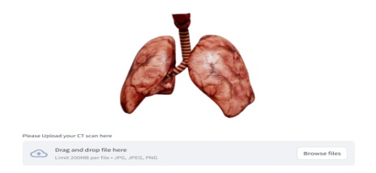
Fig 2. Webapp for Providing user Input.

Another step involves extracting features from patient ct images to compare them for disease prediction and analysis.
Output analysis heavily depends on the ct image data sets. The data sets we analyzed contain only necessary images after removing outlier cases which indicates the images are unique compared to all other ct images without matching characteristics. An exact output analysis becomes possible after we eliminate all the existing data.
Writing and implementing the code in python serves as the essential backend requirement for extracting similarities among different ct images datasets.
The user needs to input information through the web application before hitting the submit button. A user interface will present the detected disease following lung cancer,covid infections or either no cancer and no covid findings.

Fig 3. Different CT Images

Different dataset categories perform a crucial function in image analysis because they include valid dataset, test dataset and train dataset.
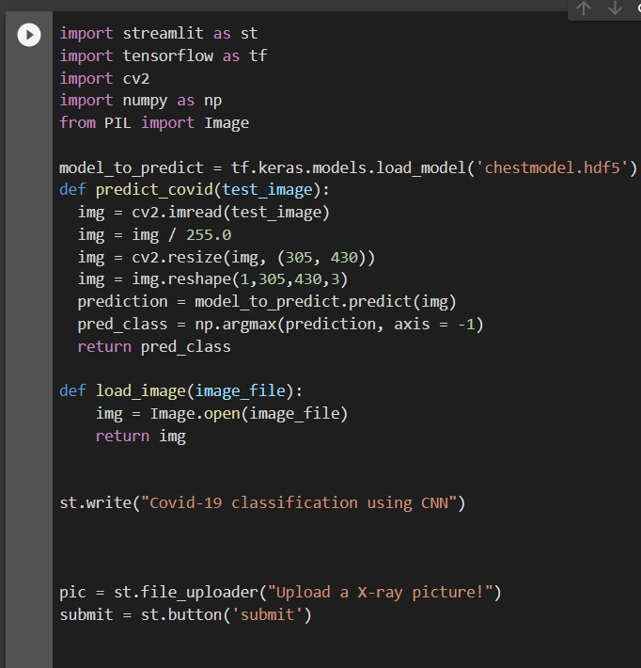
Fig 4. Backend code 1

The implementation of the web platform utilized HTML along with python script while providing an easy-to-use and friendly interface for patient image uploading accessible to all users.
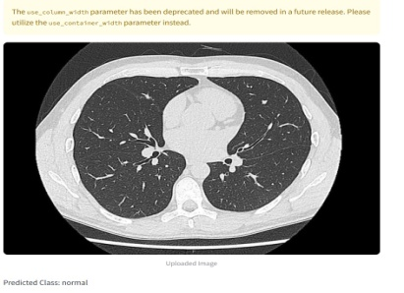

fig 5. predicted output in the web app
The fig 3 shows multiple cancer datasets which serve as essential elements for feature extraction before moving to the fig 4 where we show the backend python code that functions as the main analytical tool for output predictions and analysis. Finally in fig 5 we display a CT image of a cancer-affected patient who receives an accurate output diagnosis of cancer.
CONCLUSION
The paper established a summary of current deep learning research in medical image analysis. The discussion covers vital achievements throughout these specific areas. The discussion starts by giving a complete breakdown of fundamental deep learning concepts. A tutorial explaining similar Deep Learning concepts in image analysis exists in this review segment. The paper established a complete summary of medical imaging techniques which utilize deep learning principles. The research examined CNN-based deep learning methods which developed clinical applications through object recognition and picture classification and segmentation and registration tasks. The research incorporated many technical points that encompassed data issues alongside sturdy systems and persistent model learning as well as system parameter adjustment for hospital connections and data transformation requirements. The DNN classifier surpasses traditional classifiers since it demonstrates higher accuracy rates according to research review reports. Visual radiologic evaluation cannot discover complex imaging patterns yet AI-based image evaluation finds these patterns with ease.

ACKNOWLEDGMENTS
Thank you to our respected school and department for granting access to needed laboratory resources that helped us complete the research. My professor provided essential guidance that enabled me to achieve successful completion of my project.

REFERENCES
- Suganyadevi, S., Seethalakshmi, V., &amp; Balasamy, K. (2022). A review on deep learning in medical image analysis. International Journal of Multimedia Information Retrieval, 11(1), 19-38.
- Sistaninejhad, B., Rasi, H., &amp; Nayeri, P. (2023). A Review Paper about Deep Learning for Medical Image Analysis. Computational and Mathematical Methods in Medicine, 2023.
- Liu, X., Gao, K., Liu, B., Pan, C., Liang, K., Yan, L., ...
&amp; Yu, Y. (2021). Advances in deep learning-based medical image analysis. Health Data Science.
- Puttagunta, M., &amp; Ravi, S. (2021). Medical image analysis based on deep learning approach. Multimedia tools and applications, 80, 24365-24398.
- Sarvamangala, D. R., &amp; Kulkarni, R. V. (2022). Convolutional neural networks in medical image understanding: a survey. Evolutionary intelligence, 15(1), 1- 22.
- Sharif, M. I., Khan, M. A., Alhussein, M., Aurangzeb, K., &amp; Raza, M. (2021). A decision support system for multimodal brain tumor classification using deep learning. Complex &amp; Intelligent Systems, 1-14.
- Phaphuangwittayakul, A., Guo, Y., Ying, F., Dawod, A. Y., Angkurawaranon, S., &amp; Angkurawaranon, C. (2022). An optimal deep learning framework for multi- type hemorrhagic lesions detection and quantification in head CT images for traumatic brain injury. Applied Intelligence, 1-19.
- Tappero, C., Thali, M. J., &amp; Schweitzer, W. (2020). The possibility of vi identifying brain hemorrhage in putrefied bodies with PMCT. Forensic Science, Medicine and Pathology, 16, 571-576.
- Yu, J., Park, S., Kwon, S. H., Cho, K. H., &amp; Lee, H. (2022). AI-based stroke disease prediction system using ECG and PPG bio-signals. IEEE Access, 10, 43623-43638.
- Lamba, R., Gulati, T., Alharbi, H. F., &amp; Jain, A. (2021). A hybrid system for Parkinson’s disease diagnosis using machine learning techniques. International Journal of Speech Technology, 1-11.

